
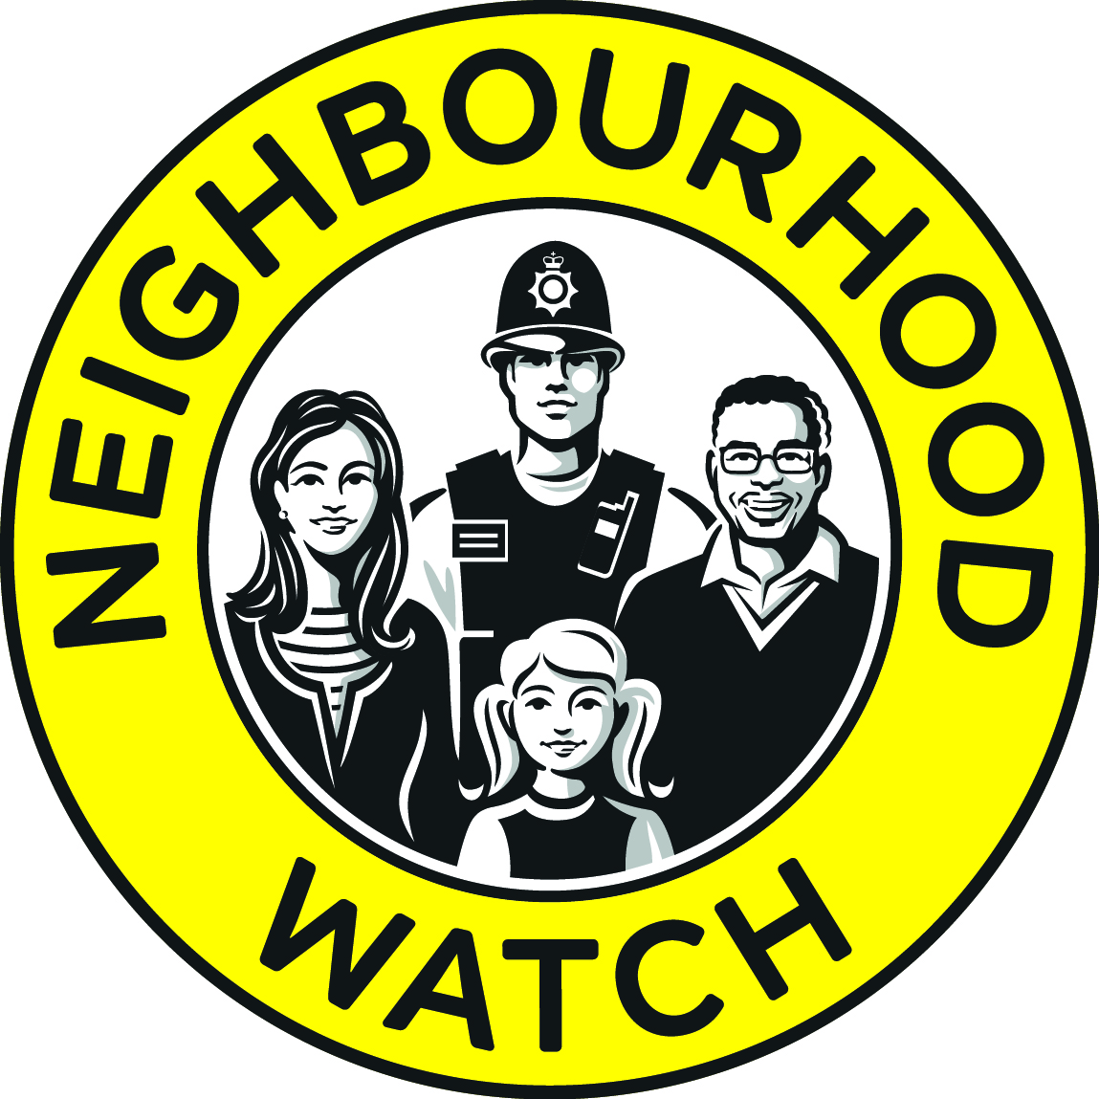

Police and Crime Commissioner for Derbyshire
A proposal for the
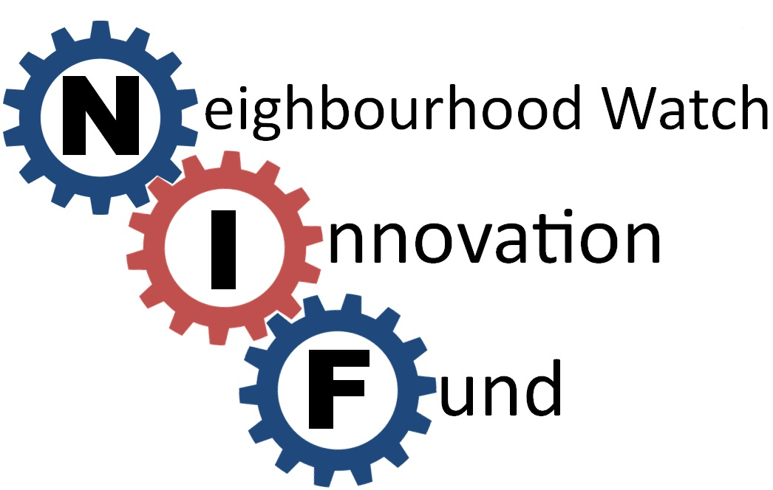
2020-2021

Round 1: Proposed timeframe for NIF applications
Applications open: | 22nd July
Submission of outline proposal: | 15th September
Shortlisting completed by: | 30th September
Final Submission to PCC by: | 15th October
Final Decisions made by: | 12th November
Funding made to successful Schemes/Support Groups: | 30th November

Round 2: Proposed timeframe for NIF applications
Applications open: | 16th November
Submission of outline proposal: | 4th January
Shortlisting completed by: | 18TH January
Final Submission to PCC by: | 1st February
Final Decisions made by: | 17th February
Funding made to successful Schemes/Support Groups: | 1st March

During 2020-2021, the Police and Crime Commissioner (PCC) for Derbyshire has allocated a total of £5000 to Neighbourhood Watch in Derbyshire for small (up to £300 each) innovative proposals for preventing crime and expanding watch schemes across the county.
With this allocated fund, Derbyshire Neighbourhood Association Trust (DNWAT) and the PCC are looking to fund proposals for projects that will promote ideas for caring and resilience in communities across Derbyshire.
An example of this would be, to provide a way of helping protect homes and property by providing security advice and products to those in need of assistance. In addition, ideas for growing NHW schemes and expanding pre-existing schemes into new areas including encouraging new members to join will also be considered.
DNWAT are inviting single applications for up to £300 from local NHW schemes and support groups.
The first stage will be to complete a proposal setting out an initial outline of the idea, including costs.
Once these proposals have been reviewed, a number will be shortlisted and DNWAT may ask for further information. Those selected will then be reviewed by the PCC and a final decision made.
The deadline by which outline proposals need to be submitted is 12 noon 15th September 2020.
The Attached form at App 1 should be completed and emailed to the Chair of Derbyshire NHW Association Trust:
Lfarrar7@hotmail.com

Proposals received after the deadline will not be considered

Appendix 1
1. Contact information
Name of NHW Scheme or Support Group: ______________________
Name of lead Coordinator: ______________________________
Address:______________________________
Contact Tel:______________________________
Contact Email: _____________________________

2. Where will the proposal be located?
Policing Division | Please tick the area
South Division
Derby City
South Derbyshire
Erewash
North Division
Amber Valley
Chesterfield
North East Derbyshire
Bolsover
Derbyshire Dales
High Peak

3. What is the amount you are applying for?
(Please note that all expenditure MUST be inclusive of VAT where applicable).

Appendix 1 (cont’)

4. What is your idea?
In the box below, please provide an outline proposal (100 words max.) Please ensure you have included the following sections:
- What does your idea achieve?
- Is there a timescale for your idea?
- How the money will be spent?
- Who will benefit and how?

Please remember if you are selected you may be asked for further information before a final decision is made
Thank –you!! Remember the closing date for receipt of applications is 15th September 2020.

