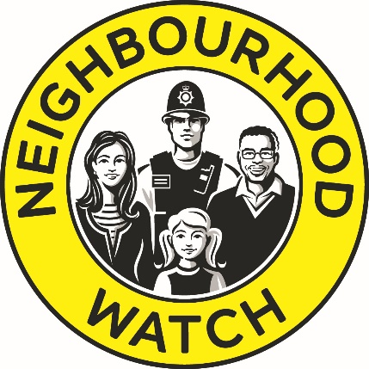


Neighbourhood Watch Support Fund
2023-2024

Application Pack

Derbyshire Police and Crime Commissioner Angelique Foster has announced details of a new funding boost to help neighbourhoods prevent crime and increase safety.
Neighbourhood Watch schemes across Derbyshire are being invited to apply for a grant to support their efforts to protect communities and deter crime.
The funding, unveiled at Derbyshire’s Neighbourhood Watch AGM, is being made available through Police and Crime Commissioner Angelique Foster’s Neighbourhood Watch Support Fund 2023-2024 and will be allocated in grants of up to £250 per proposal.
Police and Crime Commissioner Angelique Foster has pledged to deliver stronger and more effective neighbourhood policing across Derbyshire, bolstering the number of volunteers and citizens who support the work of the Police and increase visibility in the county’s communities.
The funding scheme supports her goals to provide neighbourhoods with additional resources and tools to proactively deter crime and keep local people safe.
The Neighbourhood Watch Support Fund is aimed at increasing the number of Neighbourhood Watch schemes in operation across Derby and Derbyshire as well as boosting membership and supporting existing schemes.
Applications will be screened by the Derbyshire Neighbourhood Watch Association Trust (DNWAT) before being submitted to the Office of the Police and Crime Commissioner (OPCC).

Eligibility Criteria:

- Applications are only valid from registered Neighbourhood Watch schemes based in Derbyshire.

- Each application must ensure the deliverables contribute towards one or more of the following:
- Improving community safety
- Promoting Neighbourhood Watch
- Supporting the operation of existing Neighbourhood Watch schemes

- The maximum amount which can be applied for is £250 (inclusive of VAT).

Aim
The overarching aim of the fund is to increase the number of watch schemes in Derbyshire and Derby City and the membership base.

The deadline by which applications need to be submitted is 3RD September 2024
The Attached form at Appendix 1 should be completed and emailed to the Derbyshire NHW Association Trust: hello@derbyshireneighbourhoodwatch.co.uk

Proposals received after the deadline will not be considered

Appendix 1
- Contact information

Name of NHW Scheme
Name of Lead Coordinator
Address
Contact telephone
Contact E-mail

2. Where will the proposal be located?
Policing Division | Please tick the area
South Division
Derby City
South Derbyshire
Erewash
North Division
Amber Valley
Chesterfield
North East Derbyshire
Bolsover
Derbyshire Dales
High Peak

3. What is the amount you are applying for?
(Please note that all expenditure MUST not exceed £250 and be inclusive of VAT where applicable).

Appendix 1 (cont’)

4. Please indicate which of the following your proposal is looking to address. One or more can be selected.

Insert X below
Improving Community Safety

Promoting Neighbourhood Watch

Supporting the operation of existing Neighbourhood Watch schemes

What is your idea?
In the box below, please provide an outline proposal (500 words max). Please ensure you have included the following sections:
- What does your idea achieve?
- Is there a timescale for your idea?
- How the money will be spent? (include full cost breakdown for each deliverable item and the overall total – (maximum being £250).
- Who will benefit and how?

Please remember if you are selected you may be asked for further information before a final decision is made
Thank –you!! Remember the closing date for receipt of applications is: 3RD September 2023.

